Supply Chain Digitization
Week 6 | Session 5: Classification Tree in Python — Full Hands-On Code

Session Agenda
- Libraries used — pandas, sklearn, matplotlib
- Step 1: Import data (maintenance.csv → DataFrame)
- Step 2: List variables, define X (features) and Y (target)
- Step 3: Split into training (70%) and test (30%) data
- Step 4: Build classification tree (Gini, max_depth=2)
- Step 5: Print / visualise the decision tree
- Step 6: Predict on test data, read confusion matrix, compute accuracy
- How to run in Google Colab
Session Context — Theory to Code
- Sessions 3 & 4: Showed the output of the model and explained HOW it is built (Gini, node splitting, stopping criteria)
- Session 5: Reproduce the EXACT same output using Python code — closes the loop from theory to implementation
- Platform: Google Colab — browser-based Python environment, no local installation needed
- Data file: maintenance.csv — 1000 rows, 8 columns (same dataset used in Sessions 3 & 4)
- Expected output: Same decision tree structure, same Gini values, same node counts as shown in the theory slides
Libraries Used
Table 1: Python libraries imported in this session and their purpose
Library | Import As / From | Purpose in This Model
pandas | import pandas as pd | Data manipulation and analysis. Used to read CSV file and create DataFrame.
sklearn (scikit-learn) | from sklearn import... | Scikit-Learn: Machine learning library. Provides Decision Tree Classifier, train-test split, confusion matrix, and accuracy score algorithms. Also features various algorithms like clustering, random forests, logistic regression etc.
matplotlib | import matplotlib.pyplot as plt | Plotting library. Used to visualise and print the decision tree diagram.
Step 1 — Import Data
- File: maintenance.csv | Rows: 1000 | Columns: 8
- Columns: age, utilization, MTBF_value, unplanned_downtime, oil_contamination, overhauling_schedule_compliance, schedule_lubrication_compliance, machine_failure

import pandas as pd
from sklearn import tree
df = pd.read_csv("maintenance.csv")
df
# df now has 1000 rows × 8 columns
# All features + target variable loaded into DataFrame df

- pd.read_csv(): Reads the CSV file and stores it as a DataFrame (df) — a table with labelled rows and columns
- After this step: df has 1000 rows and 8 columns including the target (machine_failure)
Step 2 — List Variables, Define X (Features) and Y (Target)
# List all 8 columns
print(list(df.columns)) #or list(df.columns)
# Output: [age, utilization, MTBF_value, unplanned_downtime,
# oil_contamination, overhauling_compliance,
# schedule_lubrication_compliance, machine_failure]
# Define feature (independent) variables — remove target column
X_features = list(df.columns)
X_features.remove("machine_failure")
# Create feature DataFrame (7 columns, 1000 rows)
X_df = df[X_features]
# Define X and Y
X = X_df # 7 independent variables (features)
Y = df.machine_failure # 1 dependent variable (target)

- X: 7 independent variables (all columns except machine_failure) — used to predict Y
- Y: machine_failure column — what the model must predict (0 = not failed, 1 = failed)
- X_df: 1000 rows × 7 columns. df has 8 columns; X_df has 7 (machine_failure removed).
Step 3 — Split into Training and Test Data (70/30)
from sklearn.model_selection import train_test_split
X_train, X_test, Y_train, Y_test = train_test_split(
X, Y,
test_size=0.30, # 30% for test, 70% for training
random_state=42 # optional: for reproducibility
)
# X_train: 700 rows × 7 cols → used to BUILD the model
# X_test: 300 rows × 7 cols → used to VALIDATE the model
# Y_train: 700 rows × 1 col
# Y_test: 300 rows × 1 col

Table 2: All data variables — rows, columns, and purpose
Variable | Content | Rows | Columns | Used For
df | Full dataset (all 8 columns) | 1000 | 8 | Starting point — full data
X_df (X) | Independent variables (7 features) | 1000 | 7 (no Machine_Failure) | Features to train on
Y | Dependent variable (Machine_Failure) | 1000 | 1 | Target to predict
X_train / Y_train | 70% of X and Y (randomly selected) | 700 | 7 / 1 | Train the model
X_test / Y_test | 30% of X and Y (randomly selected) | 300 | 7 / 1 | Validate / test the model

- Why split? If the model is trained and tested on the same data → artificially inflated accuracy (overfitting). Test data must be held out and NEVER used during training.
- test_size=0.30: 30% = 300 observations for testing. 70% = 700 for training. These match the node counts in Sessions 3 & 4.
- Random split: Python randomly assigns rows to training vs. test → prevents selection bias
★ Exam tip: Always explain WHY train-test split is needed (to avoid overfitting and get an unbiased estimate of model accuracy on new data). Mention 70/30 and that test data is never seen by the model during training.
Step 4 — Build the Classification Tree
from sklearn.tree import DecisionTreeClassifier
# Initialise the classifier
clf = DecisionTreeClassifier(
criterion="gini", # Use Gini index to split nodes
max_depth=2 # Stop at depth 2 (2 levels below root)
)
# Train (fit) the model on training data
clf.fit(X_train, Y_train)
# clf is now the trained decision tree model

- criterion="gini": Use Gini impurity index to decide which variable and cutoff to split each node. Could also use "entropy".
- max_depth=2: Stop splitting after reaching 2 levels from the root. Prevents overfitting. Produces 4 leaf nodes.
- clf.fit(X_train, Y_train): Trains the model — the algorithm finds the best splits using 700 training observations
- Note: Only X_train and Y_train are used here. X_test and Y_test are not touched yet.
★ criterion + max_depth are the two key hyperparameters. Gini is computationally cheaper than entropy and gives similar results in most cases. max_depth=2 was chosen to match the theory from Sessions 3 & 4.
Step 5 — Print / Visualise the Decision Tree
import matplotlib.pyplot as plt
from sklearn import tree
plt.figure(figsize=(15, 10))
tree.plot_tree(
clf,
feature_names=X_train.columns,
class_names=["Machine Not Failed", "Machine Failed"],
filled=True
)
plt.show()

- plt.figure(figsize=(15,10)): Sets the size of the output figure — 15 wide × 10 tall (in inches)
- tree.plot_tree(): Renders the decision tree visually — shows splits, Gini values, sample counts, and class predictions at each node
- feature_names: Labels axes with actual column names (oil_contamination, MTBF_value, utilization) instead of generic feature indices
- class_names: Labels the prediction outputs — [0 = Not Failed, 1 = Failed]
- filled=True: Colours the nodes — darker = more dominant class in that node. Makes the tree easier to read visually.

- Output matches Session 3 diagram exactly: Same splits (oil contamination → MTBF / utilisation), same Gini values, same sample counts
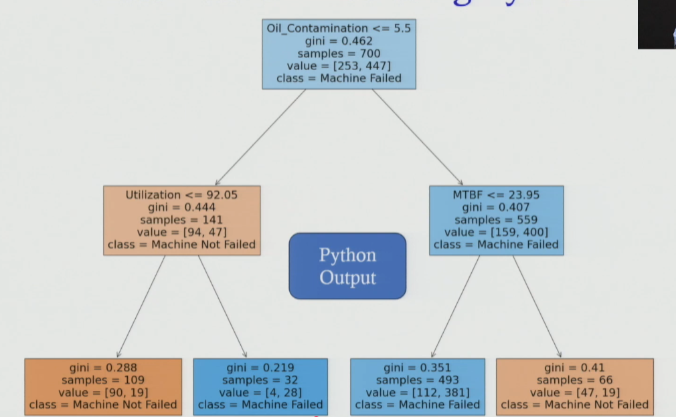
Verifying Python Output — Matches Theory
- Node 0 (root): 700 samples | Gini = 0.462 | Split: oil_contamination ≤ 5.5
- Node 1 (oil ≤ 5.5): 141 samples | Gini = 0.44 | Majority class: Not Failed (94 vs 47)
- Node 2 (oil > 5.5): 559 samples | Gini = 0.40 | Majority class: Failed (400 vs 159)
- Node 3 (leaf — util ≤ 92.05): 109 samples | Gini = 0.28 | Predict: Not Failed
- Node 4 (leaf — util > 92.05): ~35 samples | Gini = 0.21 | Predict: Failed (88%)
- Node 5 (leaf — MTBF ≤ 23.95): 493 samples | Gini = 0.35 | Predict: Failed (77%)
- Node 6 (leaf — MTBF > 23.95): 66 samples | Gini = 0.41 | Predict: Not Failed (71%)

- All values match: Python output is identical to the manually constructed tree from Sessions 3 & 4

Step 6 — Predict on Test Data and Evaluate Model
6a. Generate Predictions
from sklearn.metrics import confusion_matrix, accuracy_score
# Use the trained model to predict on test data
Y_pred = clf.predict(X_test)
# Compare actual vs. predicted (first few rows)
import pandas as pd
comparison = pd.DataFrame({"Actual": Y_test, "Predicted": Y_pred})
print(comparison.head())
# Sample output:
# Obs Actual Predicted
# 521 0 0 ← Correct
# 737 0 0 ← Correct
# 660 1 1 ← Correct
# 935 1 0 ← Wrong (False Negative)
# ... ...

- clf.predict(X_test): Applies the trained model to the 300 test observations — produces predicted Y values
- Note: Some predictions will be wrong (0 predicted as 1, or 1 predicted as 0) — this is expected. Accuracy quantifies how many are correct.
6b. Confusion Matrix
cm = confusion_matrix(Y_test, Y_pred)
print(cm)
# Output:
# [[ 57 65]
# [ 16 162]]

Table 3: Confusion matrix — actual vs. predicted (on 300 test observations)
 | Predicted: NOT FAIL (0) | Predicted: FAIL (1)
Actual: NOT FAIL (0) | 57 ✓ True Negative | 65 ✗ False Positive
Actual: FAIL (1) | 16 ✗ False Negative | 162 ✓ True Positive

- True Negative (57): Model correctly predicted machine did NOT fail — actual also not failed
- True Positive (162): Model correctly predicted machine FAILED — actual also failed
- False Positive (65): Model predicted FAIL — actual did NOT fail (over-alarm)
- False Negative (16): Model predicted NOT FAIL — actual DID fail (missed failure — more dangerous in practice)
- Test set breakdown: Total 300 | Actual Not Failed = 122 | Actual Failed = 178
6c. Accuracy Score
acc = accuracy_score(Y_test, Y_pred)
print(acc)
# Output: 0.73
# Manual calculation:
# Accuracy = (True Negative + True Positive) / Total
# Accuracy = (57 + 162) / 300 = 219 / 300 = 0.73 = 73%

- Accuracy = 73%: 73 out of every 100 test instances are predicted correctly
- Compare to baseline: If model always predicted "FAIL" (majority class, 64%) → 64% accuracy. Model achieves 73% → meaningful improvement over naive baseline.
- Limitation of accuracy: In imbalanced datasets, accuracy alone can mislead. False Negatives (missed failures) are more costly in maintenance context — also look at Recall/Sensitivity for such problems.
★ 73% test accuracy on unseen data. Model is generalisable. Compare to 64% baseline — the tree adds real predictive value. The 16 False Negatives (missed failures) are the key risk to monitor in a plant setting.
Complete Code Reference — All Steps Together
# ── STEP 1: Import Libraries & Data ──────────────────────────
import pandas as pd
import matplotlib.pyplot as plt
from sklearn import tree
from sklearn.tree import DecisionTreeClassifier
from sklearn.model_selection import train_test_split
from sklearn.metrics import confusion_matrix, accuracy_score
df = pd.read_csv("maintenance.csv")
# ── STEP 2: Define Features (X) and Target (Y) ───────────────
X_features = list(df.columns)
X_features.remove("machine_failure")
X = df[X_features]
Y = df["machine_failure"]
# ── STEP 3: Train-Test Split ─────────────────────────────────
X_train, X_test, Y_train, Y_test = train_test_split(
X, Y, test_size=0.30)
# ── STEP 4: Build Classification Tree ───────────────────────
clf = DecisionTreeClassifier(criterion="gini", max_depth=2)
clf.fit(X_train, Y_train)
# ── STEP 5: Print the Tree ───────────────────────────────────
plt.figure(figsize=(15, 10))
tree.plot_tree(clf,
feature_names=X_train.columns,
class_names=["Not Failed", "Failed"],
filled=True)
plt.show()
# ── STEP 6: Predict & Evaluate ───────────────────────────────
Y_pred = clf.predict(X_test)
cm = confusion_matrix(Y_test, Y_pred)
acc = accuracy_score(Y_test, Y_pred)
print("Confusion Matrix:\n", cm)
print("Accuracy:", acc)

How to Run in Google Colab
- Step 1: Open browser → go to colab.research.google.com → sign in with Google account
- Step 2: New notebook → upload maintenance.csv using the file upload icon (left sidebar)
- Step 3: Copy and paste the complete code above into a code cell
- Step 4: Run cells sequentially (Shift + Enter or click the ▶ button)
- Step 5: Decision tree diagram rendered in the output area. Confusion matrix and accuracy printed below.
- Expected output: Confusion matrix [[57, 65], [16, 162]] | Accuracy = 0.73

- Note on randomness: train_test_split() assigns rows randomly each run → exact counts may vary slightly unless random_state is fixed. The Gini thresholds and tree structure remain the same.
★ Exam tip: Be able to write the 6-step code outline (import → define X/Y → split → build → print → evaluate) from memory. Know what each step does. Know confusion matrix layout — True Positive, True Negative, False Positive, False Negative.

Key Terms and Concepts — Quick Reference
Term | Definition / What It Means in This Session
DataFrame (df) | A table structure in Python (pandas). Rows = observations, columns = variables.
Feature variable (X) | Independent variable used to make the prediction. Here: 7 machine parameters.
Target variable (Y) | Dependent variable being predicted. Here: machine_failure (0 or 1).
train_test_split() | sklearn function that randomly divides data into training and test sets. test_size=0.3 → 30% test.
DecisionTreeClassifier | sklearn algorithm for building classification trees. Key parameters: criterion (gini/entropy) and max_depth.
clf.fit() | Trains the model on X_train and Y_train — learns the optimal splits.
clf.predict() | Applies the trained model to new data (X_test) → returns predicted Y values.
confusion_matrix() | 2×2 matrix showing correct and incorrect predictions: TP, TN, FP, FN.
accuracy_score() | (TP + TN) / Total = proportion of correctly classified instances. Here: 0.73 = 73%.
False Negative | Model predicted NOT FAIL but machine actually FAILED. In maintenance: most dangerous error type.

Session Summary — Module 3 Lectures 3–5 Complete
- Session 3: Case study setup + decision tree OUTPUT — 4 leaf nodes, business rules, 2 worked predictions
- Session 4: HOW the tree is built — Gini index, entropy, node splitting logic, stopping criteria, overfitting
- Session 5 (this session): Python implementation — 6-step code, exact same output verified, confusion matrix, 73% test accuracy

- Complete code: 6 steps: Import data → define X/Y → split 70/30 → build tree (Gini, depth=2) → print tree → predict + evaluate
- Libraries: pandas (data) | sklearn (model + evaluation) | matplotlib (visualisation)
- Model parameters: criterion="gini" | max_depth=2
- Results: Training: 700 obs | Testing: 300 obs | Accuracy: 73% | Confusion matrix: [[57,65],[16,162]]
- Platform: Google Colab — upload CSV, run cells, get identical output
- Next module: AI/ML for demand forecasting — further predictive analytics applications in SCM

